2017-2018
Preschool Supply List
Yellow Room, Gray Room, Orange Room
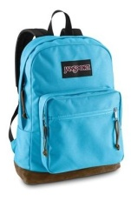  1 book bag (no small bags)- NO WHEELS. Needs to fit a folder & notebook. | 1 Reusable Lunch  bag/box for daily  healthy snack and drink  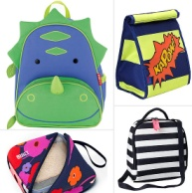 | 1 change of clothes (appropriate for the  season) in a labeled  freezer bag
3-prong poly folder with pockets  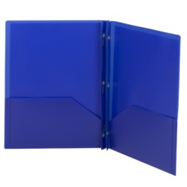 | 2-2 packs of  Elmer’s Glue Sticks | 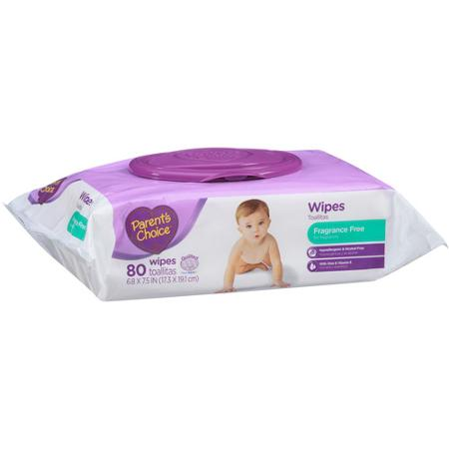  1 container of baby wipes
1 container of  Clorox Wipes | 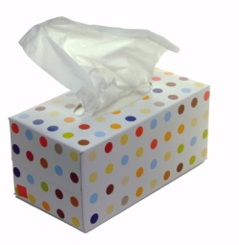  1 Box of tissues | 2 pk. of paper towels  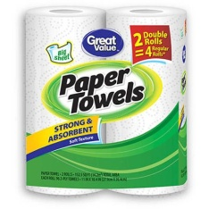
GIRLS: 3M Scotch Masking Tape  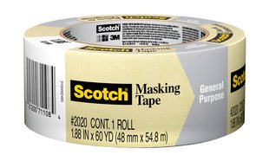 | GIRLS: 1 box of Gallon & 1 quart sized Ziploc bags  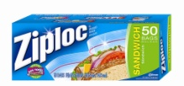 | 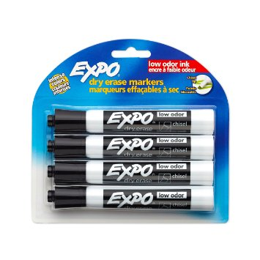  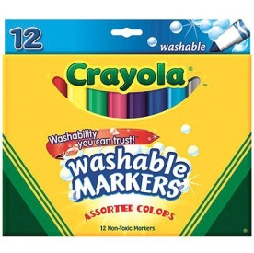  BOYS: 4 black dry erase markers
BOYS: 12 pack Crayola Washable Markers |  | ***Label bag of supplies  (not individual items)  with child’s name & bring  into Open House

