2017-2018
Preschool Supply List
Green Room (Full Day)
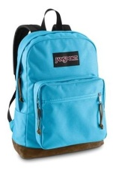  1 book bag (no small bags)- NO WHEELS. Needs to fit a folder & notebook. | 2 Reusable Lunch  bags/boxes for 2 healthy snacks, 1 lunch & drinks daily  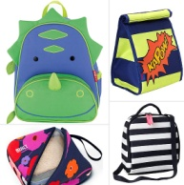 | 1 change of clothes (appropriate for the  season) in a labeled  freezer bag
3-prong poly folder with pockets  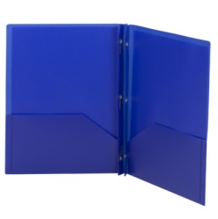 | 2-2 packs of  Elmer’s Glue Sticks | 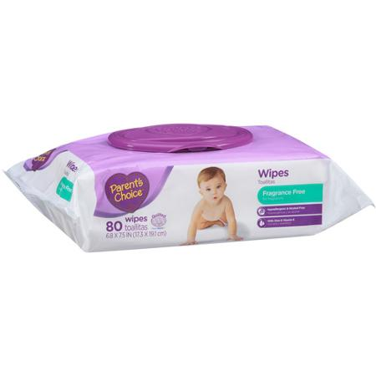  2 packages of baby wipes
2 containers of  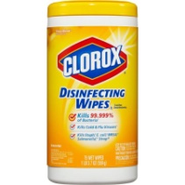  Clorox Wipes | 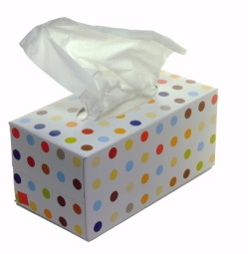  1 Box of tissues | 3 rolls of paper towels  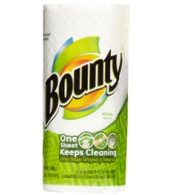
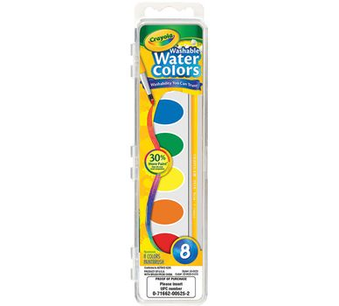  1 set of watercolor paints (8 or 16 colors) | GIRLS: 1 box of Gallon & 1 quart sized Ziploc bags  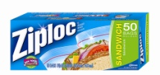 | 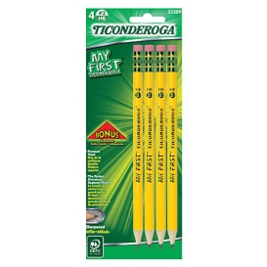  GIRLS: 1 pack My First Ticonderoga pencils
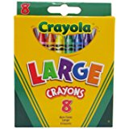  BOYS: 8 pack Crayola Large or Jumbo crayons | BOYS: 4 black dry erase markers  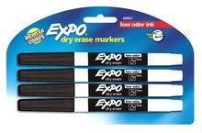 | ***Label bag of supplies  (not individual items)  with child’s name & bring  into Open House

